***Experiment 2***

**Aim:** Version Control with Git: Practice basic Git operations such as repository creation, file addition, committing changes, and pushing to a remote repository.

**1. Creating Repository:**

After installing the GitHub CLI, run the following command to create a new private GitHub repository named Learning-Git and set it as the remote origin:

**gh repo create Learning-Git --private --source=. --remote=origin**

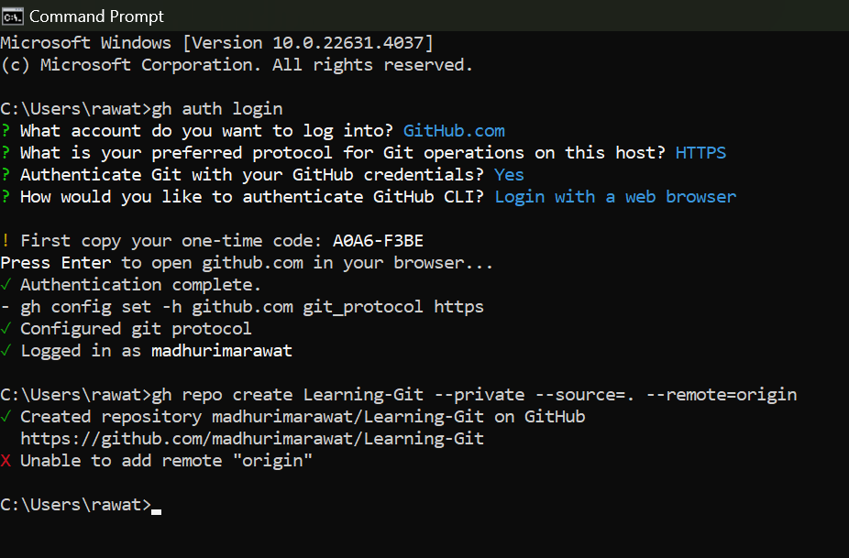

***Fig 1: Creating GitHub Repository Using GitHub CLI***

**2. Creating a local repository and pushing changes to GitHub Using Git:**

Start by initializing a new Git repository locally with **git init**, then add your files using **git add .** .

Commit the changes with **git commit -m "Initial commit"**. Finally, link to a remote GitHub repository with git remote add origin **https://github.com/madhurimarawat/Learning-Git.git** and push the changes using **git push -u origin main**.

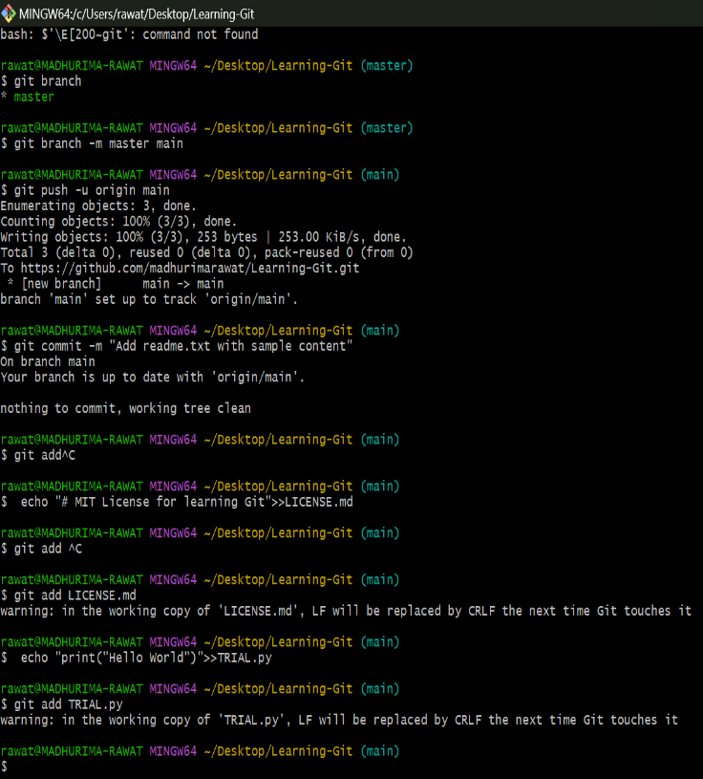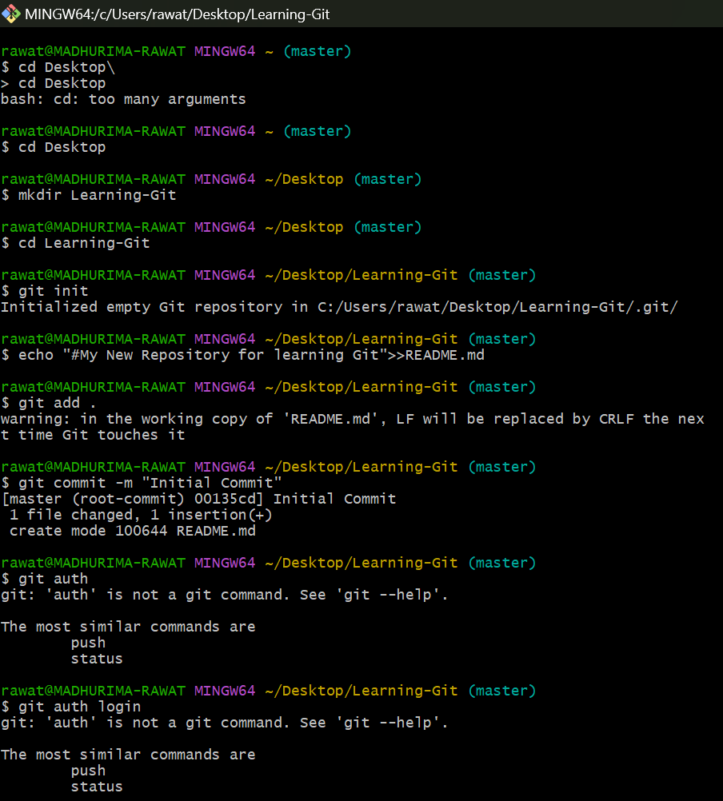

***Fig 3: Pushing Files and Making Changes***

***Fig 2: Making Local Repository***

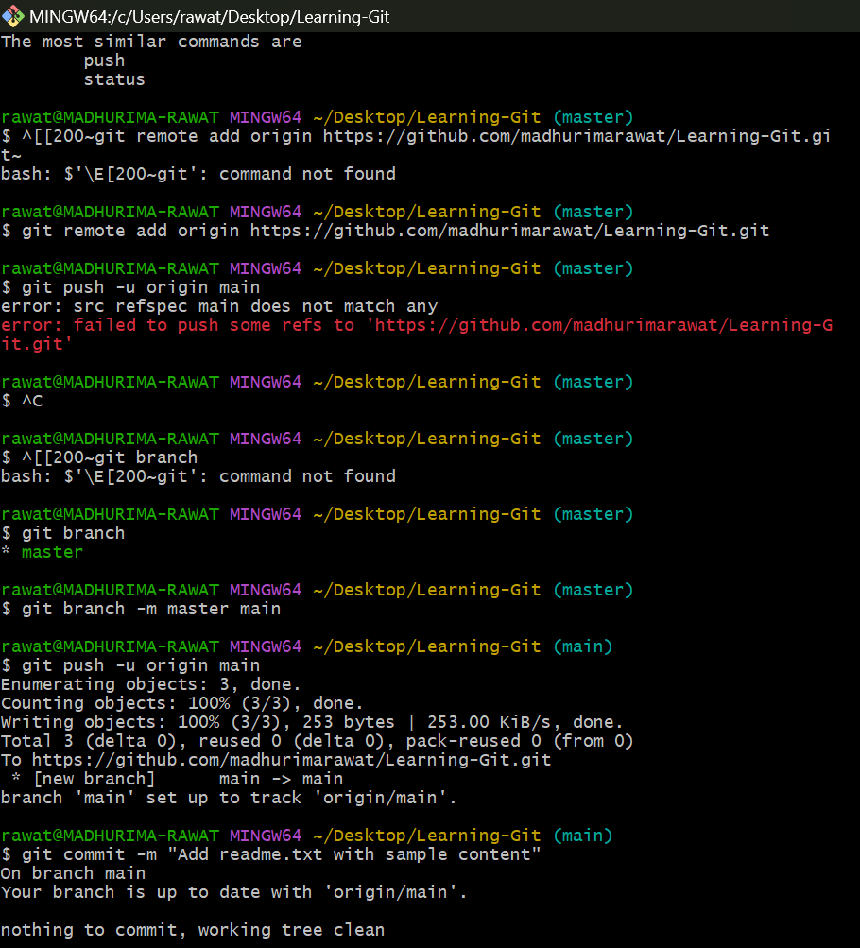

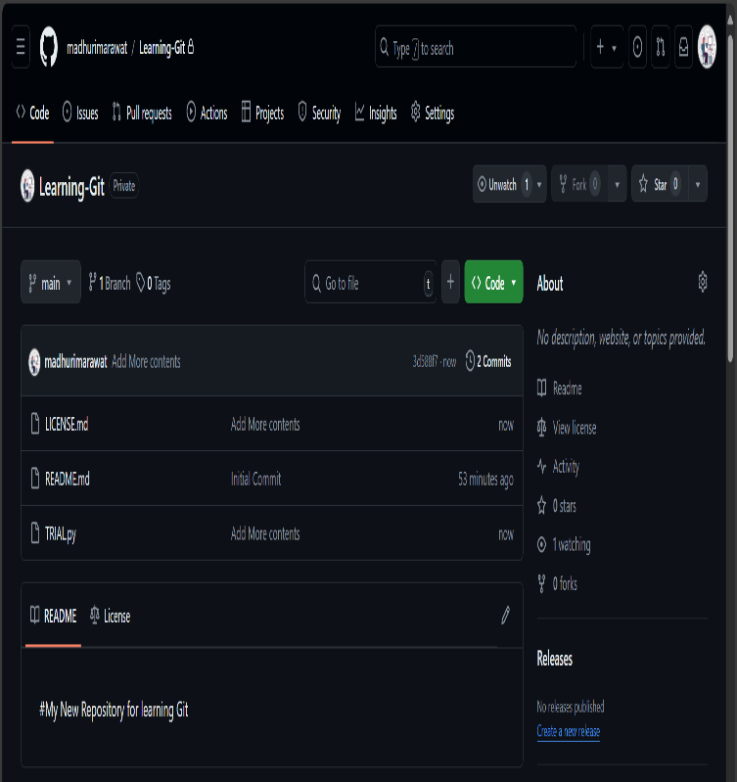

***Fig 5: Repository Updated With Changes***

***Fig 4: Committing Changes to Remote Repository***